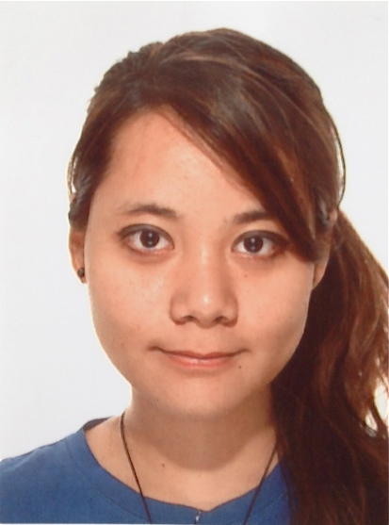 | Chikara Enggartiasti
 |  | 393272633267 | chikaramatsuda92@gmail.com | 21 years old | Milan, Milan
 | Previous |  | Designer  Design Haus
Photographer & Contributor
PT J NET TRAVEL NANKYOKUSEI
 | Education |  | Nuova Accademia di Belle Arti  Bachelor's, Design/ Creative (Sep 2014)
San Francisco State University
Bachelor's, Design/ Creative (Jan 2014)
 | Nationality |  | Indonesia  http://chikaramatsuda92.wix.com/portfolio

Experience
Aug 2013 - Jan 2014  (5 months ) | Designer  Design Haus | United States
 | During my stay in San Francisco, I was not able to work or have an internship outside of the school. Therefore, SF State have provided an internship called Design Haus. It is an official internship, in which was strongly related to the SF State International Office, and it was mandatory for exchange students who are studying design to join this program (also in order to earn extra credit). In here, I have designed many graphics, product designs and mostly flyers in order to help the school to promote the Student Exchange Study Abroad Program together with my exchange friends. One of our designs of the flyers and posters were chosen and printed to hand out to those who are interested in the program.
Aug 2011 - Aug 2013  (2 years ) | Photographer & Contributor  PT J NET TRAVEL NANKYOKUSEI | Jakarta Raya, Indonesia
"Nankyokusei" is an information magazine targeting the Japanese people living in Indonesia, writing
articles about the Indonesian culture, travel, gourmet, trends and informations.
Often focused on the photography part for advertisements. I was also was given the opportunity to write an
article about "Koninginnedag" or the "Queens Day" when traveling in the Netherlands for the special
edition about Europe.
Finally, the JAC (Japan Asian Consultants) company has used the photographs that ware taken by me for
their company calendar in 2012.
Education
Sep 2014 | Nuova Accademia di Belle Arti Milano  Bachelor's Degree in Art/Design/Creative Multimedia | Italy
 | Major | Product & Interior Design
 | Grade | On-going
 | Courses Taken: Interior Design, Product Design, Drawing for Design, AutoCAD, Rhinoceros, 3ds MAX, Adobe, Technology of Material, History of Modern art, History of Contemporary Art, History of Design, Design System, Marketing, Design Awareness, Graphic Design Workshops, Interior Design, Interaction Design
Jan 2014 | San Francisco State University  Bachelor's Degree in Art/Design/Creative Multimedia | United States
 | Major | Interior Design
 | Grade | Grade B/2nd Class Upper
International Student Exchange Program
San Francisco State University, San Francisco (USA) Fall 2013 (August 2013-January 2014)
Courses taken: Internship, Heritage of Housing and Interior Design, Housing for People with Special Needs, The Housing Structure and Its Component Parts, Interior Design Solutions--Residential, Beginning Jazz/Pop Piano
Work Experience: Outside of SF State, I have participated at an important design event called DIFFA-Dining by Design in the city of San Francisco. I was very glad that my design team appreciated my dining table design, therefore together we have developed the design that I have roughly made. The result was very satisfying. The purpose of this event was to help with fundraising to support the people with AIDS, through Design.
Skills
Advanced | AUTOCAD, RHINOCEROS, Photoshop, IMovie, InDesign, Photography
Intermediate | 3Ds MAX, Illustrator, Sketchup
Languages
Proficiency level: 0 - Poor, 10 - Excellent
Language | Spoken Written Relevant Certificates
Bahasa Indonesia (Primary) | 9 9 International Baccalaureate Program - 6/7
Japanese | 9 9 JLPT - 2nd Level
English | 9 8 TOEFL - 96/120
Italian | 4 4 Intermediate Level A2
Additional Info
Chikara Enggartiasti (also called as Chikara Matsuda), a Japanese-Indonesian born in December 12, 1992 in Jakarta, Indonesia. Started to love art when joined the first Manga School since elementary school. Later in high school, joined the IB Diploma Visual Art program. Currently studying Product & Interior Design at Nuova Accademia di Belle Arti Milano in Italy. Attended International Student Exchange Program at San Francisco State University, in California. Enjoys traveling, eating traditional food, learning new culture, skills and art. Not only enjoys designing product and interior but also designing graphics, illustrations, User Interface designs, Arduino, film making, and many more.
Site: http://chikaramatsuda92.wix.com/portoflio
About Me
Address | Viale Tibaldi 26, 20136, Milan, , Italy

